Q1. Why we need to learn a programming language?

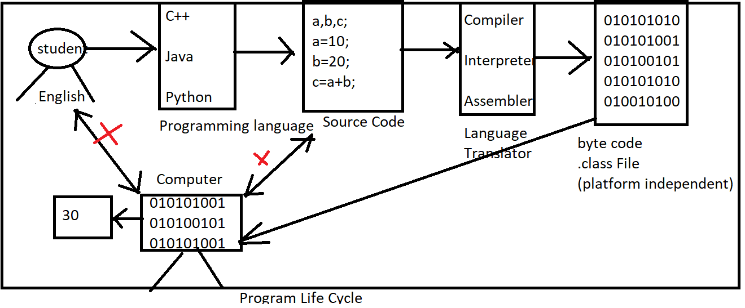

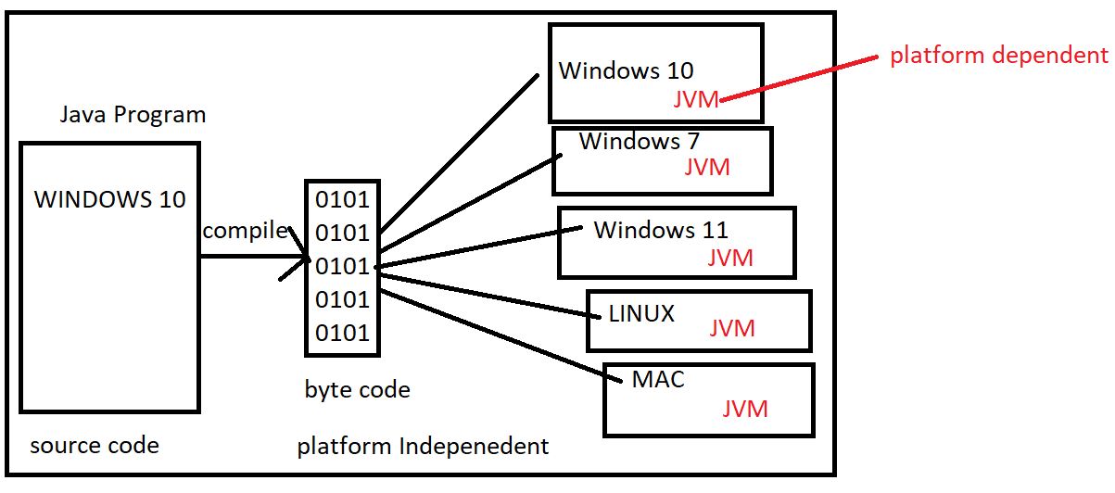

Q2. How to learn Programming language?

Ans: Learning of Programming language is very similar with learning of English Language

Ans:

1. Character Set: Character Set is a set of characters that a language can be recognize.

UpperCase : A to Z(65 To 90)

Lower case: a to z(97 to 122)

1. Tokens: Smallest Individual unit in a program.
2. Keywords: keywords are reserved words that have a special meaning to the java compiler

void,int, char, float,double,boolean, byte, short, return, if, if else, else if , switch,break,continue, while, do while, for, private, public, protected, final, static

Rules of Keywords

1. Keywords always written in lower case
2. Use space after keyword

public static void main()

1. Identifier name should not be keyword.

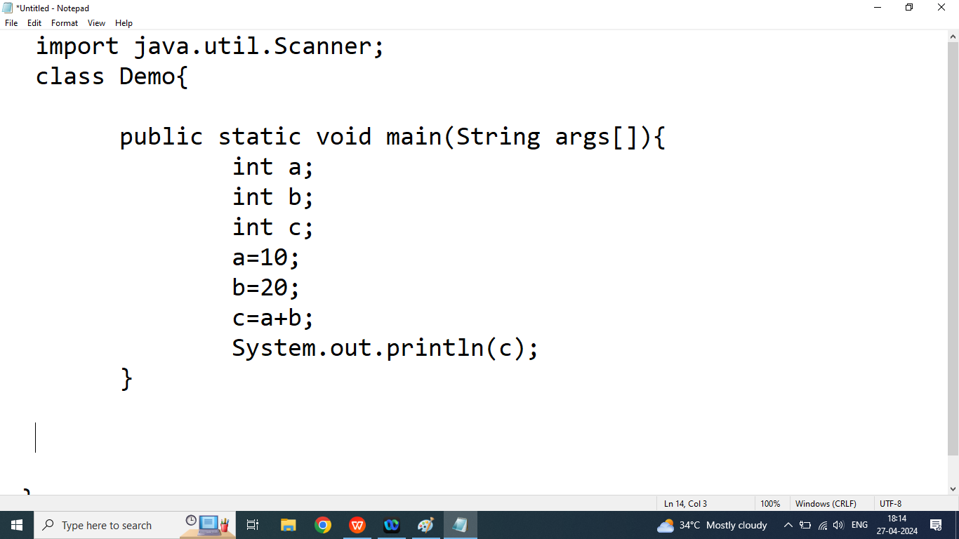

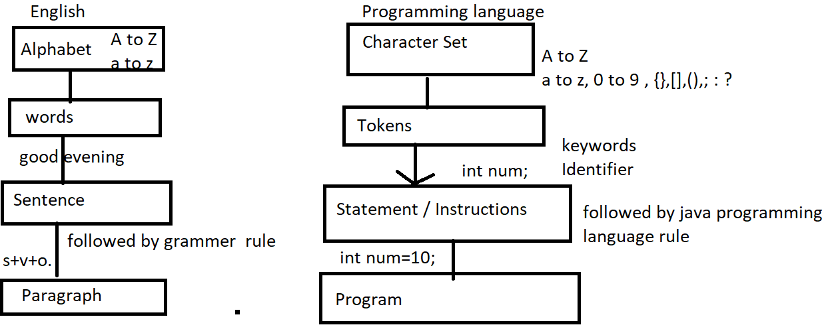

Q3. Explain Identifier in java programming?

Ans: Identifier is a name given by the programmer, Identifier name may be name of variable, name of Class, name of object name of methods name of array.

Example:

int num;

In above expression num is an identifier

Rules of Identifier

1. Identifier name may be combination of alphabet and digits but first character must be an alphabet.

Example:

int num123;//valid

int NUM123;//valid

int 123num;//invalid

int num@123;//invalid

1. In java Programming _ and $ symbol also count as an alphabet. So we can use these symbol anywhere with identifier name.

Example:

int num 123;//invalid

int num_123;//valid

int num$123;//valid

int _123;//valid

int $123;//valid

int $$;//valid

1. Identifier name should not be keyword

Example:

int WHILE;// valid

int while;//invalid